

**CY2002**

**Digital Forensics**

**Assignment 01**

**Hands-On Projects**

**Submitted by:** Mirza Humayun Masood

**Roll number:** I22-1749

**Date:** 30/8/2024

**Table of Contents**

• **Introduction** 2

• **Details and Steps** 2

• **Summary** 2

• **References** 2

# **Introduction**

In this assignment we were given 6 hands on projects to investigate in autopsy so we can get a better understanding of the tool and basics of Digital Forensics.

**Note**: Table of content should be updated automatically. Just click on table of contents and click on update table.

# **Details and Steps**

## Hands-On Project 1-1

So, in this project, it was case of a death of A person’s Girlfriend. so, I started Autopsy and followed the instructions given in the Book.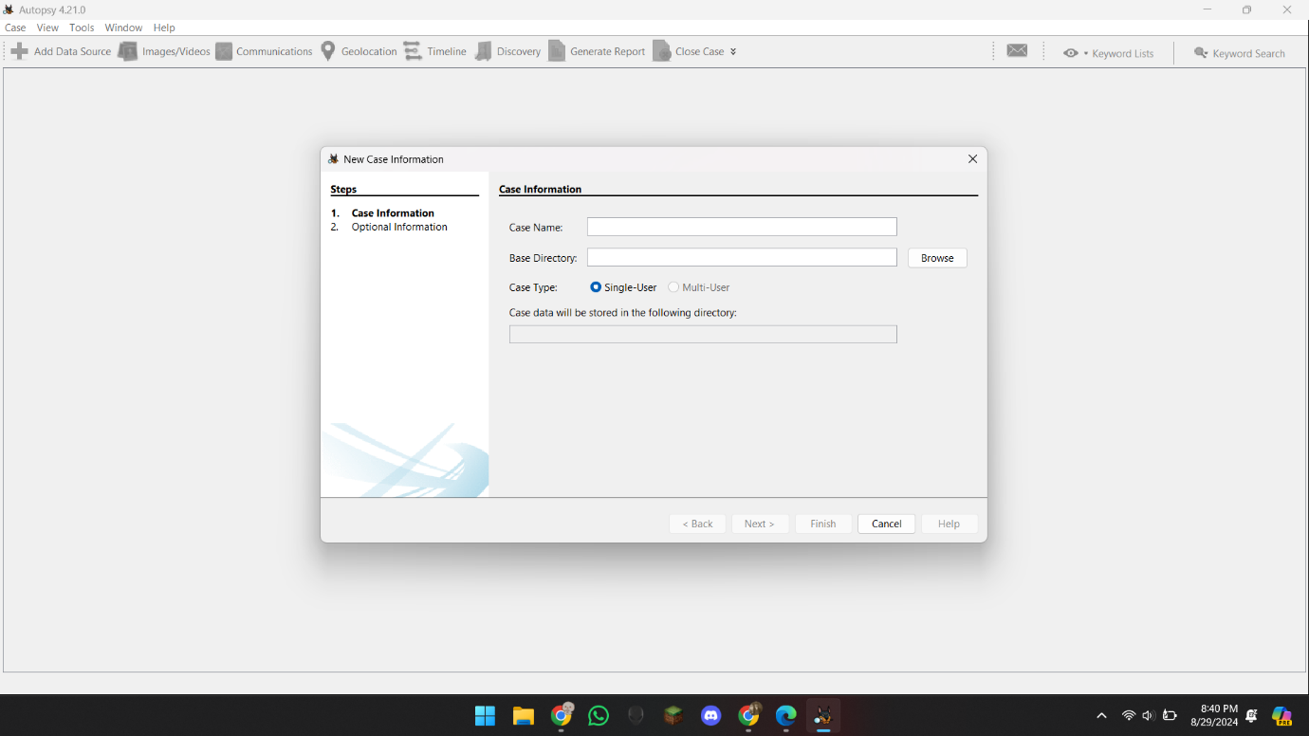

So here I added the Project name as given in the book.

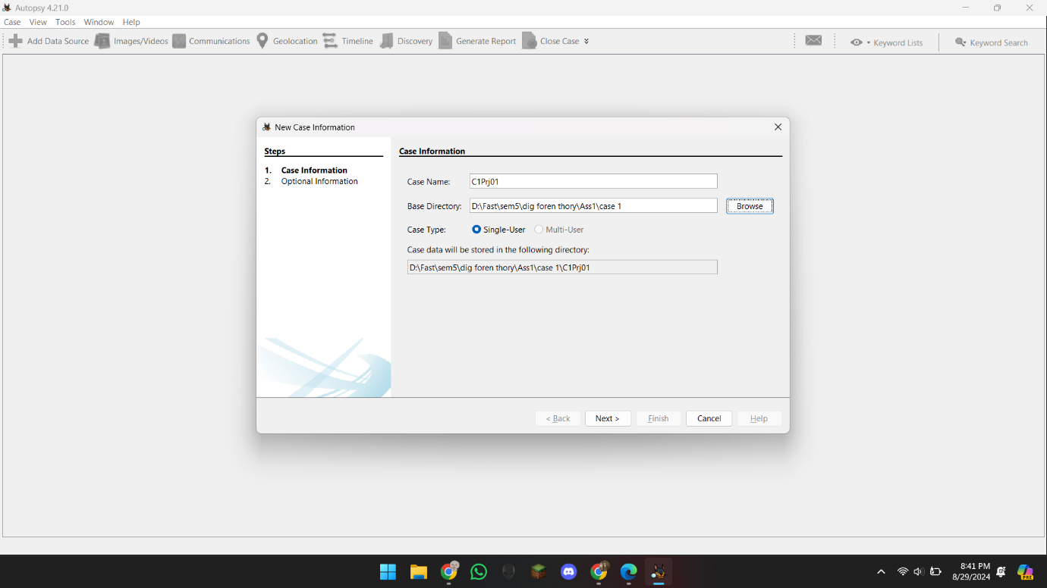

Then it asked to add a data souce and I did.

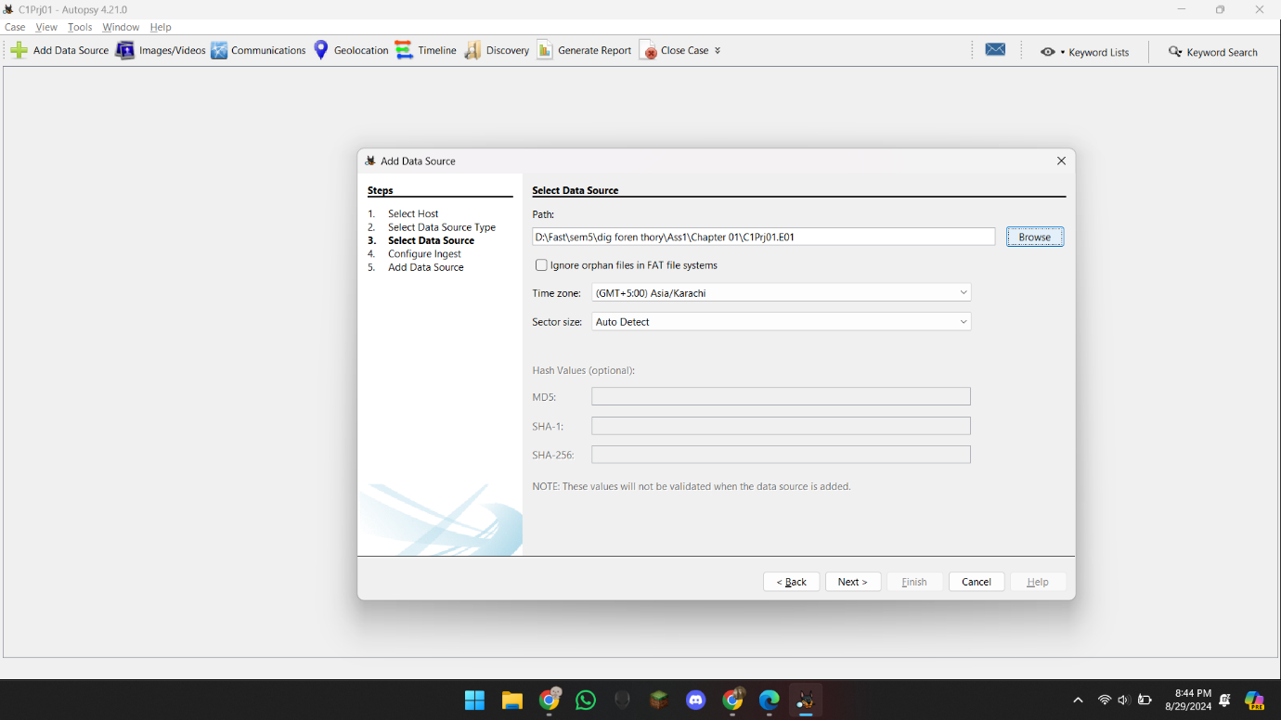

And the selected all Configure Ingest Modules and imported the project.

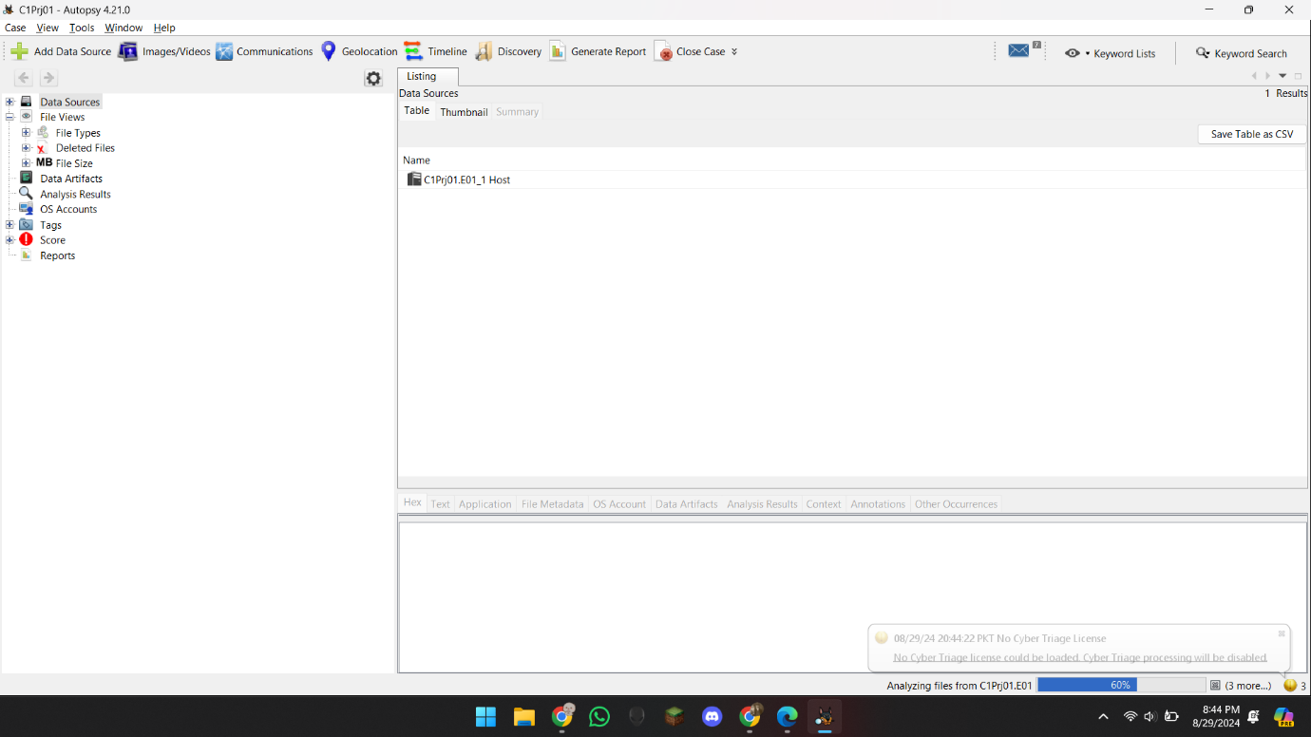

And then as instructed in the book, I Expanded all the File types, images and stuff.

Then there I found 2 files, an Excel file, and Text file, so I exported em and here they are.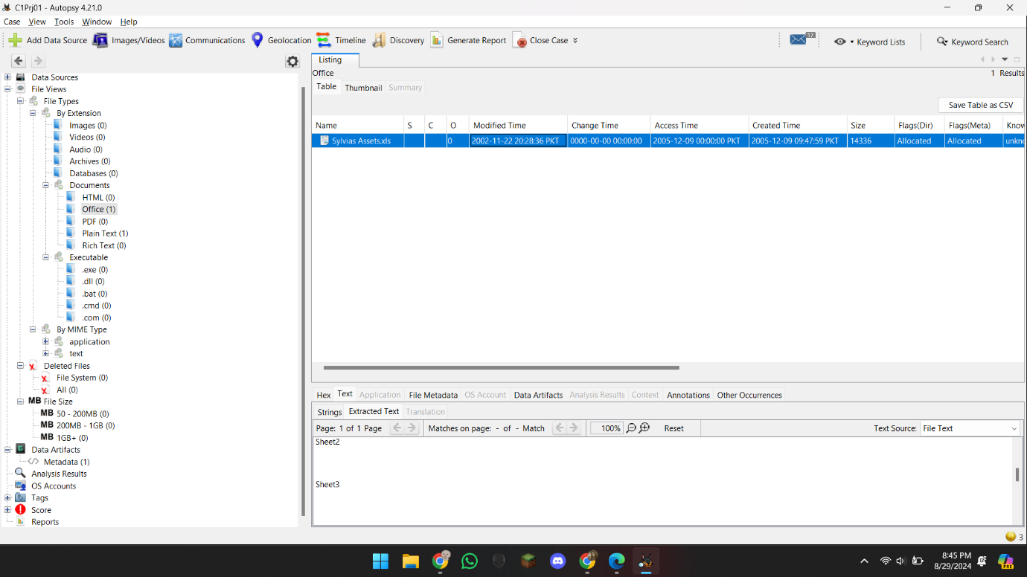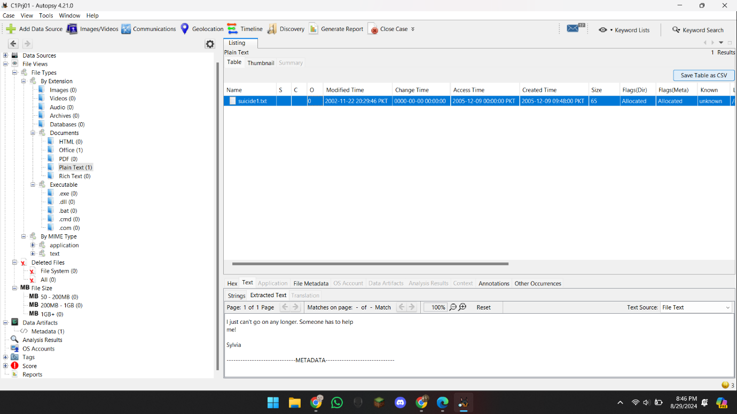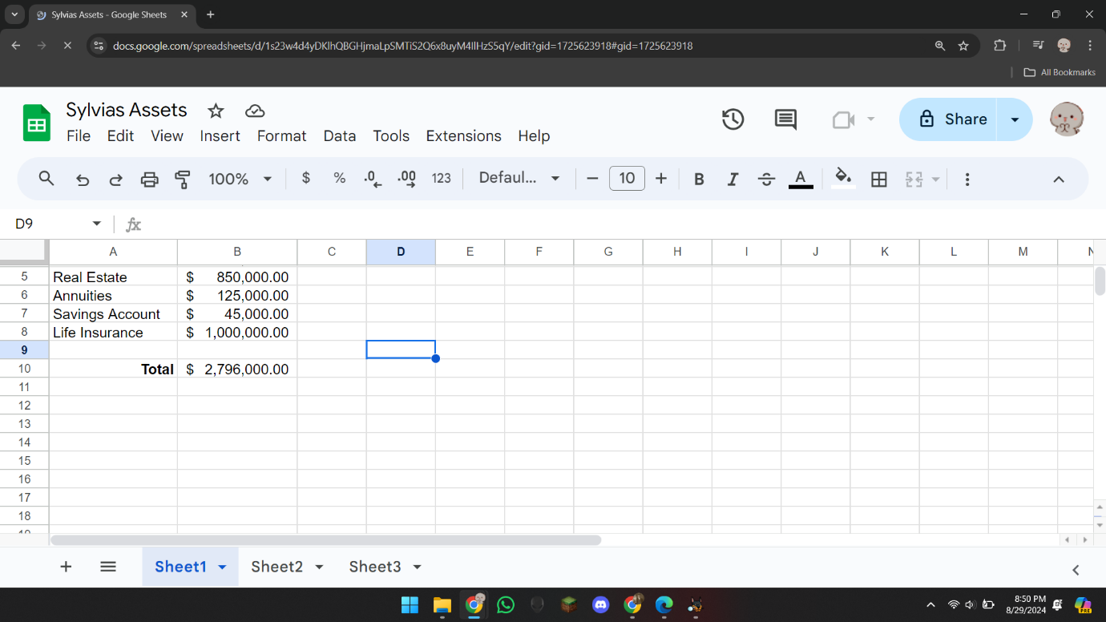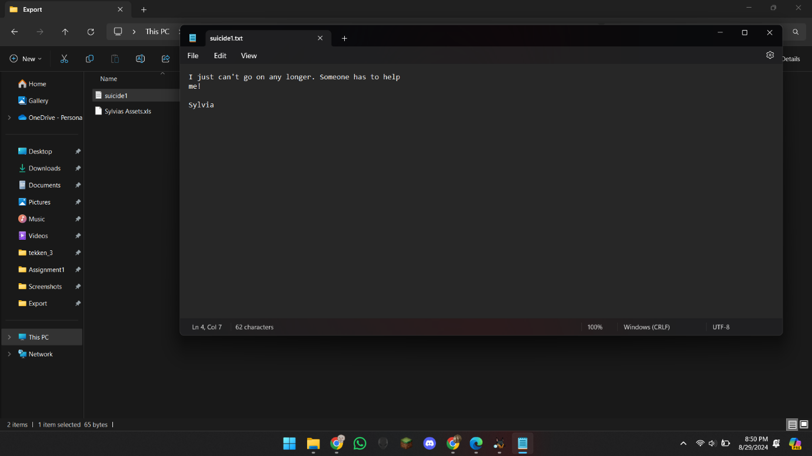

So here The case 1 ends.

## Hands-On Project 1-2

So this case was about A person leaving the company and stealing some confidential data. So here I Imported the project in autopsy and continued.

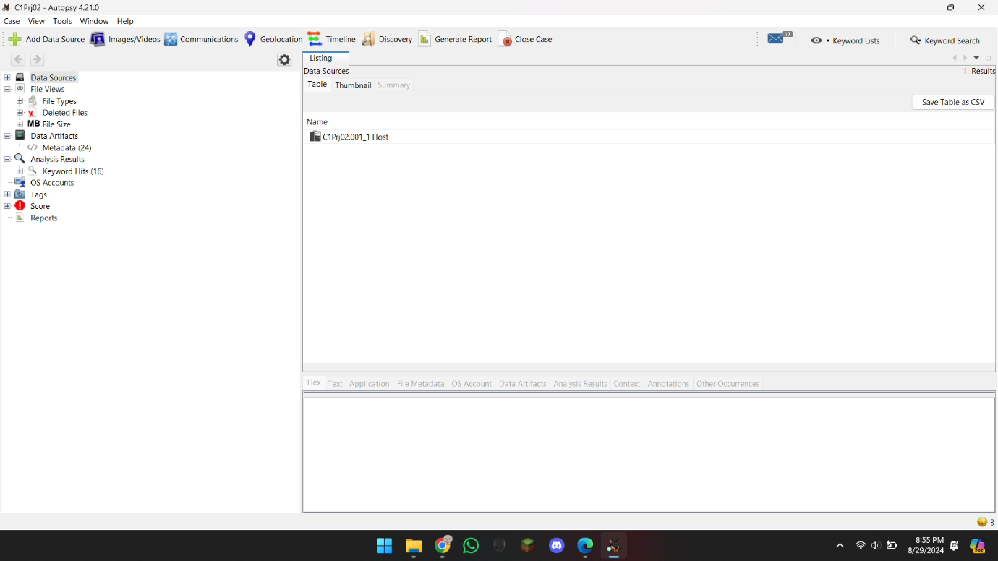

After importing I went to keyword search, and searched “Confidential” and found some files.

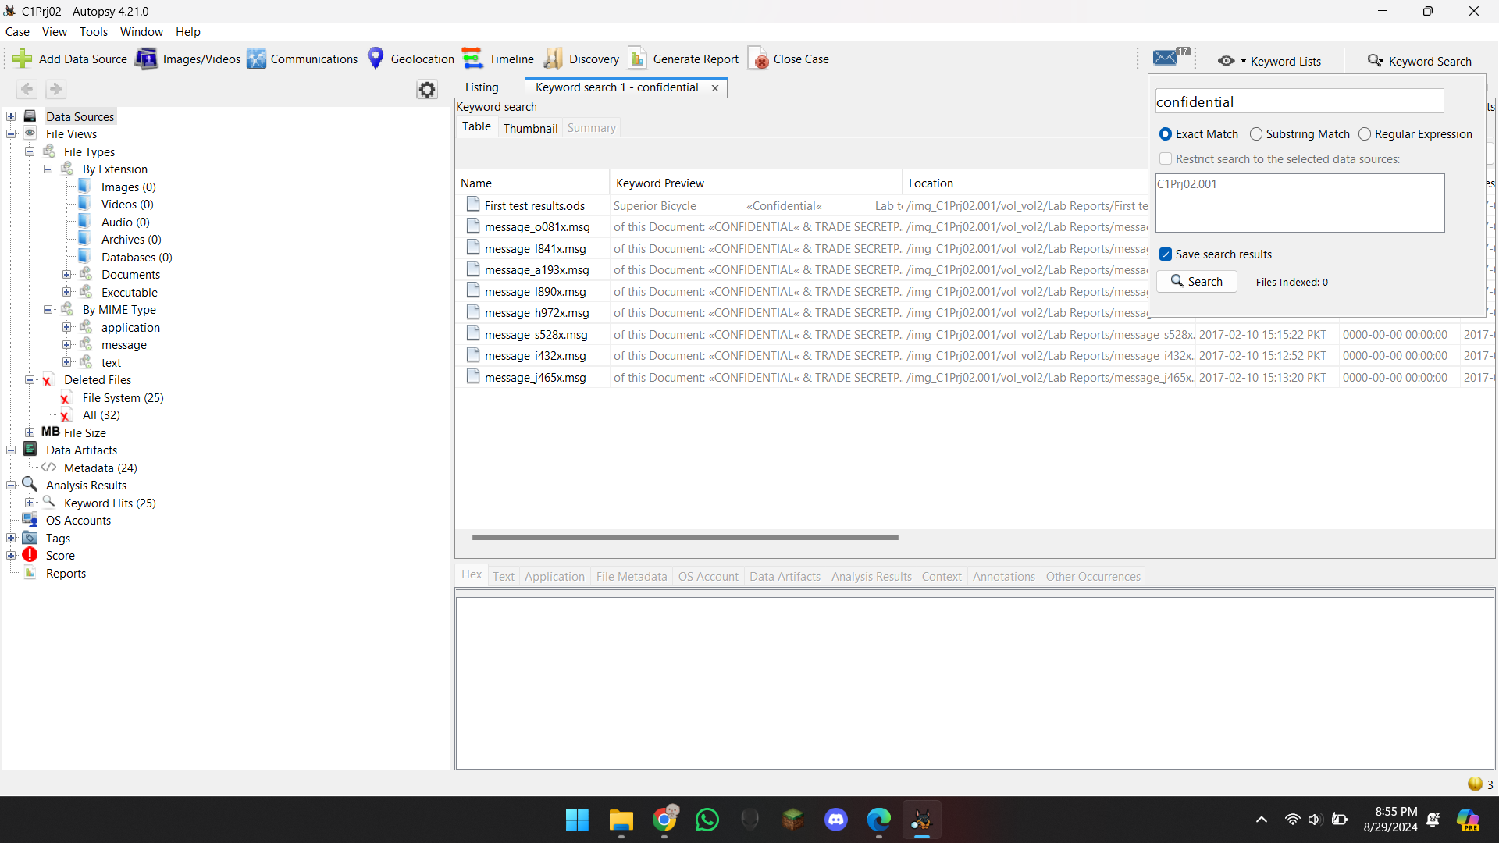

I selected all the files, and then Made a new tag, and tagged em all.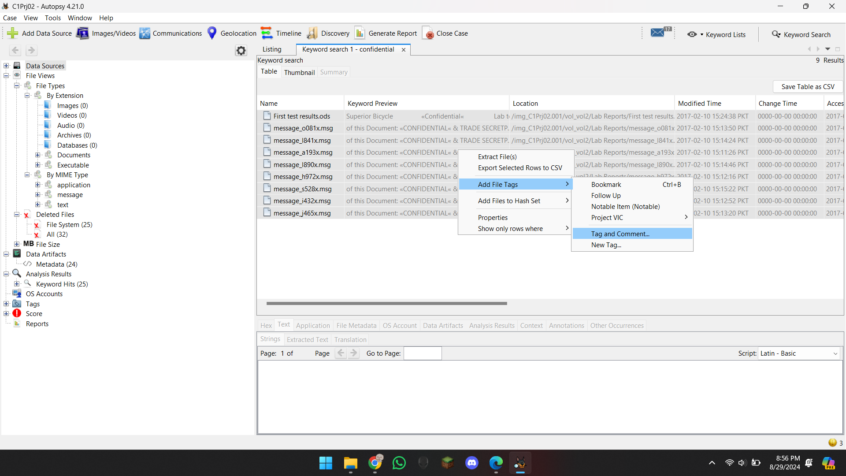

And then Named the Tag “Recovered Office Documents” and Generated the report in Excel.

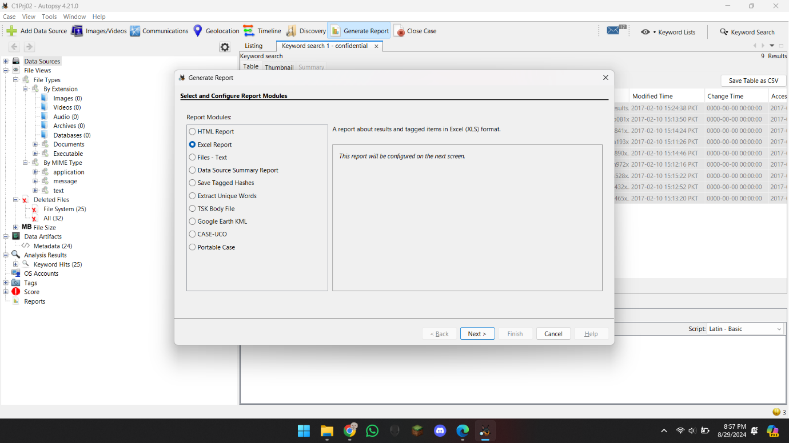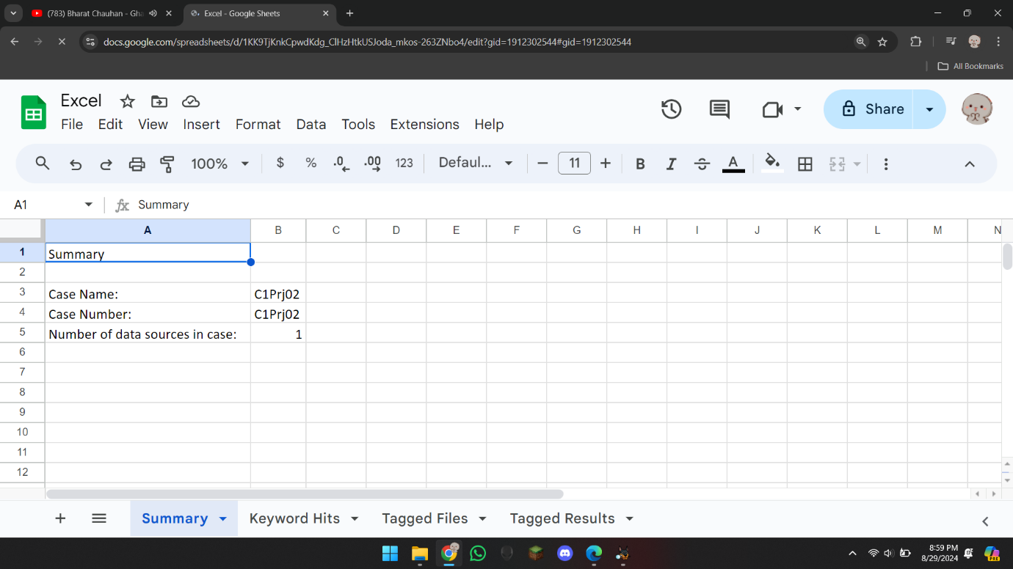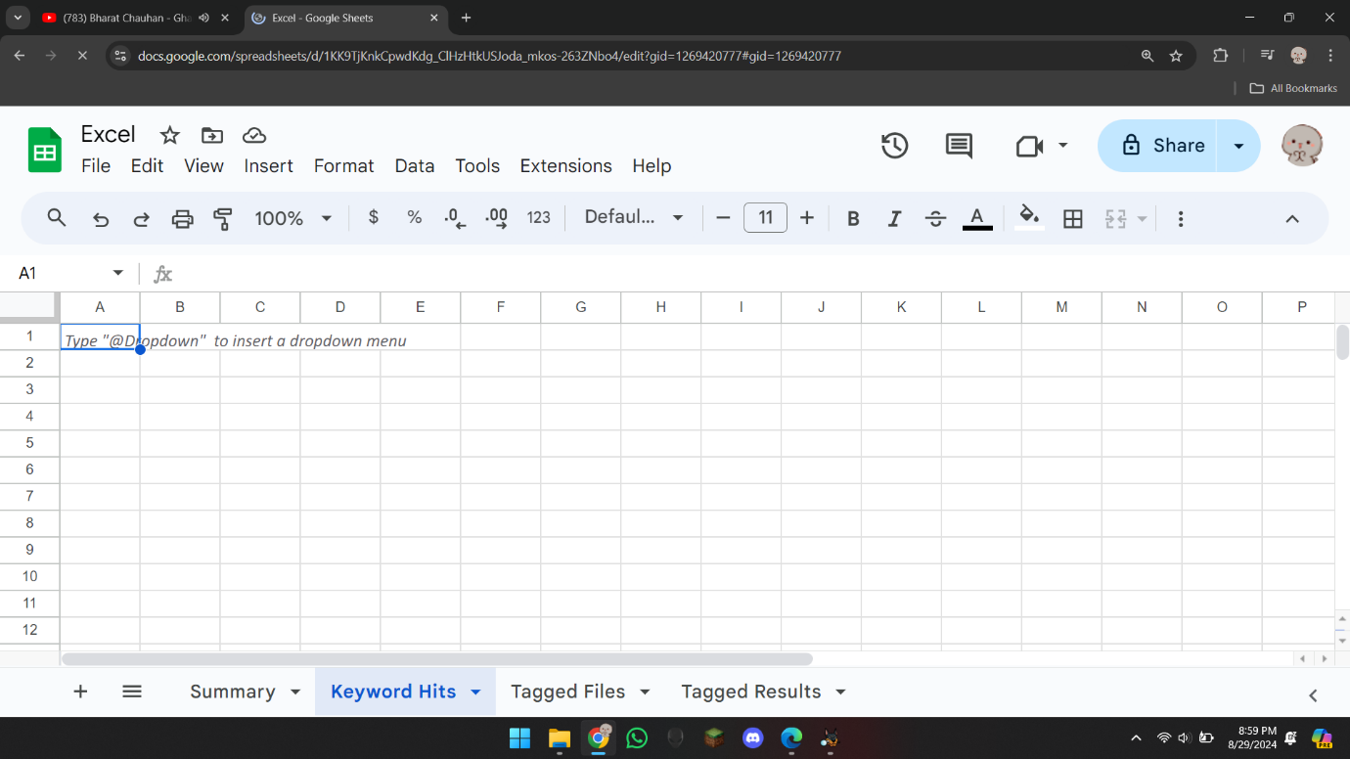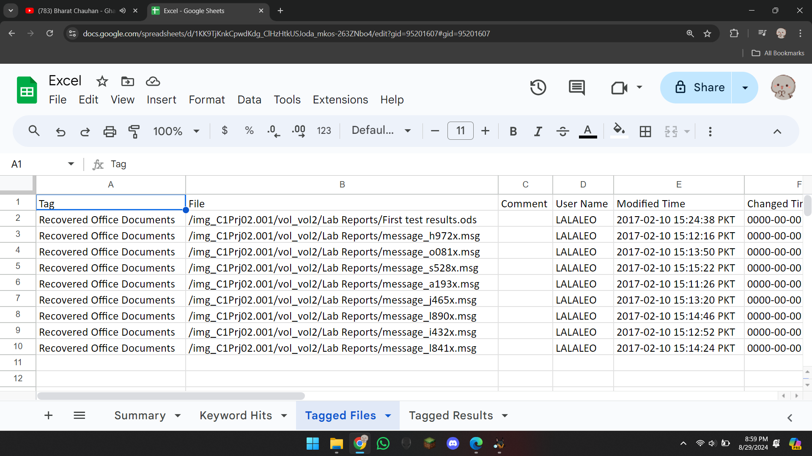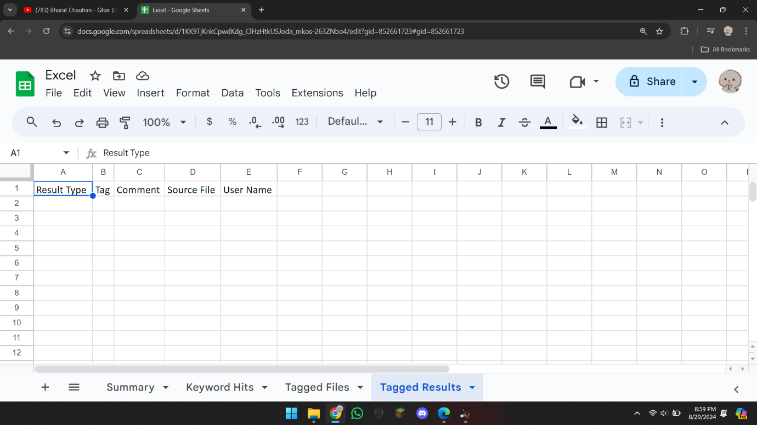

And here it was The results of Excel File.

## Hands-On Project 1-3

So, in this Case Ms. Olsen got an anonymous USB congaing some evidence which shows that Ralph Williams blackmailed them to get the job. So as usual I opened the Project in Autopsy and started the work.

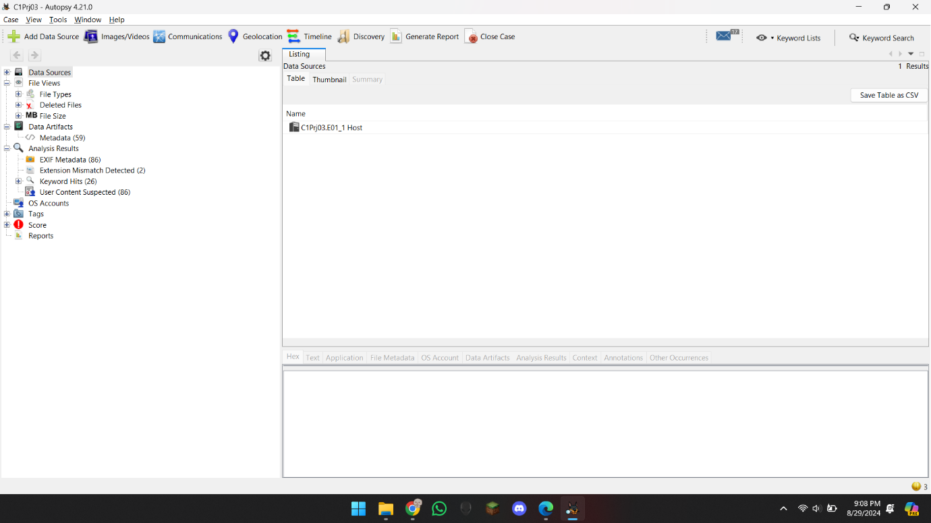

Here I went to find the images, sorted them by date, and looked for 2006 pics, and found some of boat pics.

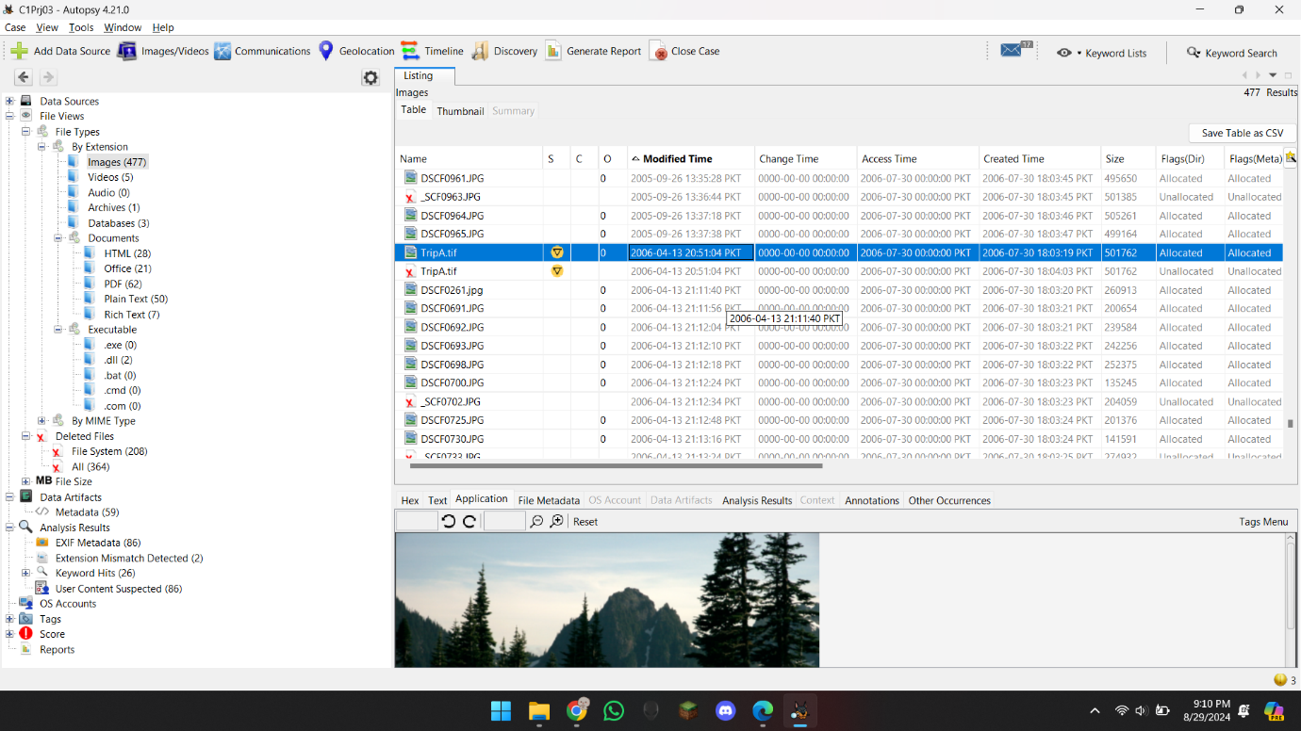

Then I quick tagged them by follow up , and generated the report in HTML.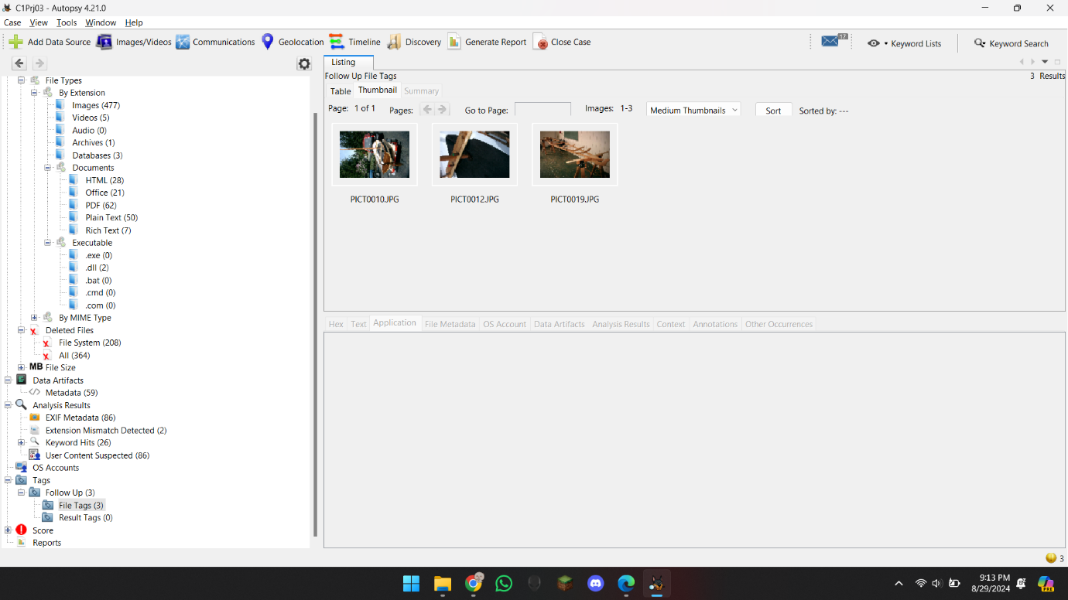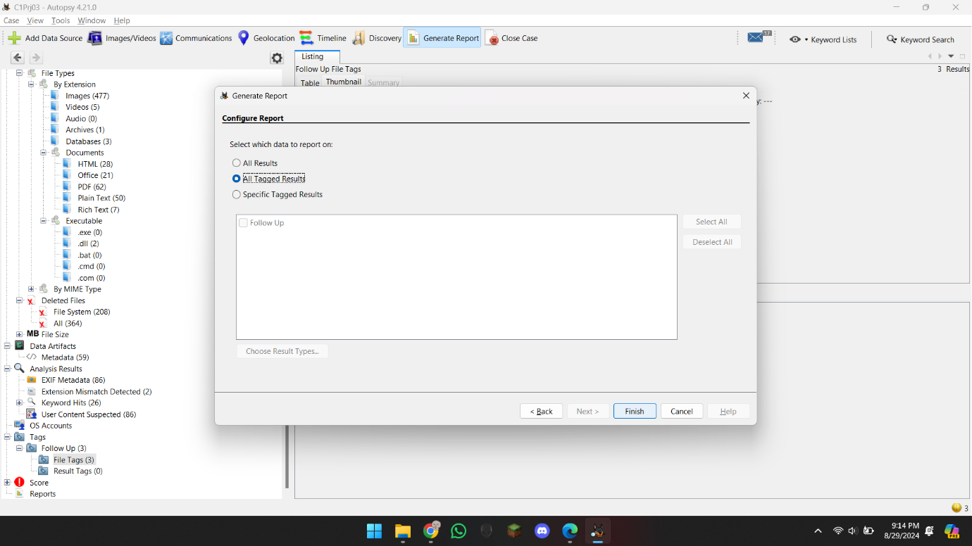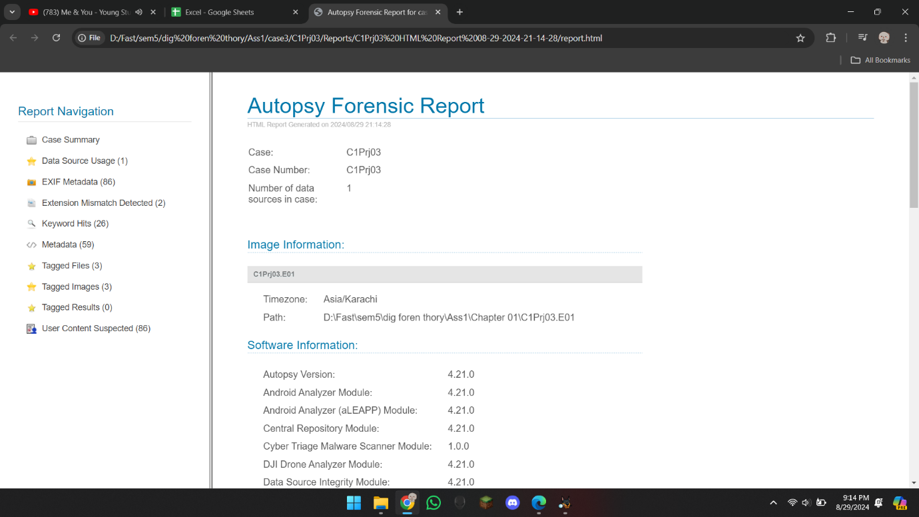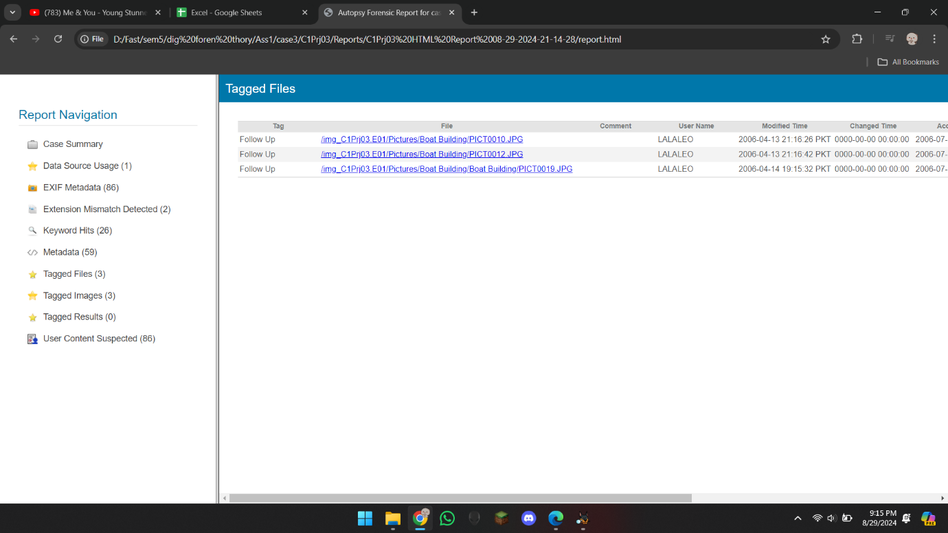

## Hands-On Project 1-4

In this case I wanted to Files that was not deleted and was allocated. So I just opened the project in Autopsy.

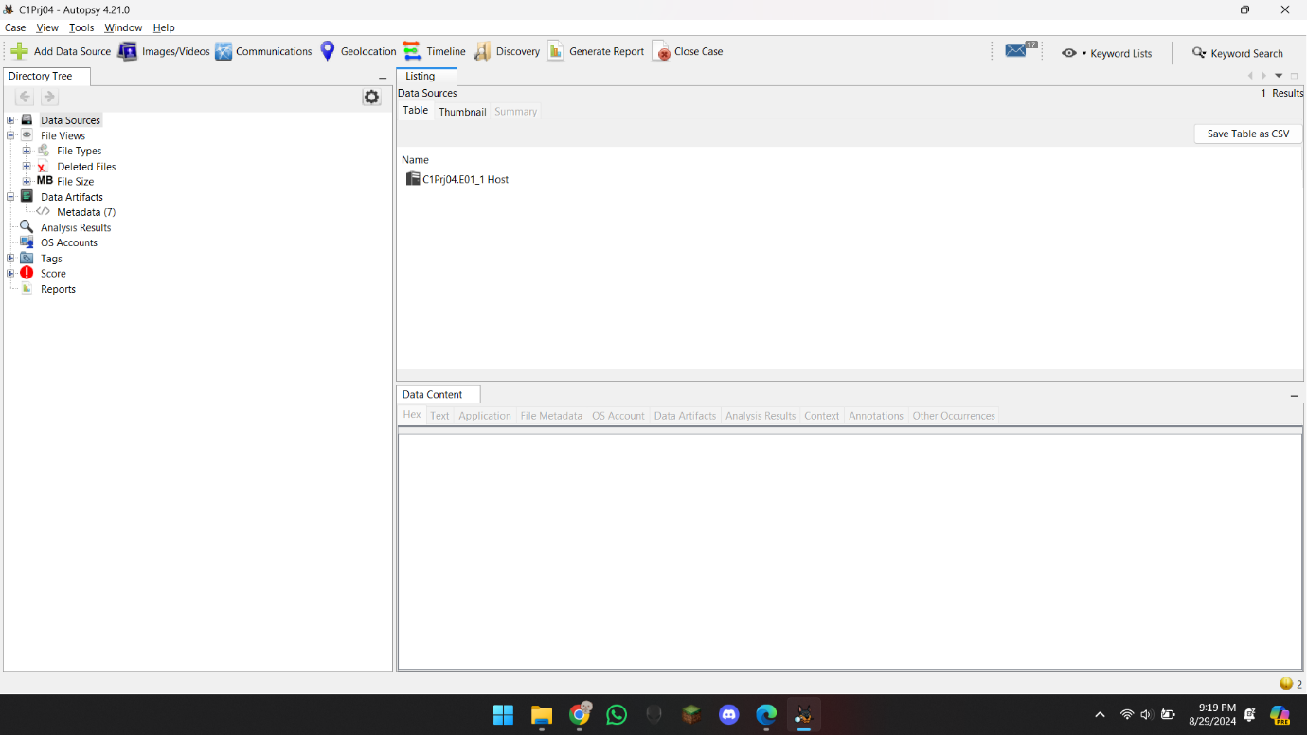

Expanded the tree , and went to Extensions , Sorted the files in Flag(meta), and exported all the Allocated files.

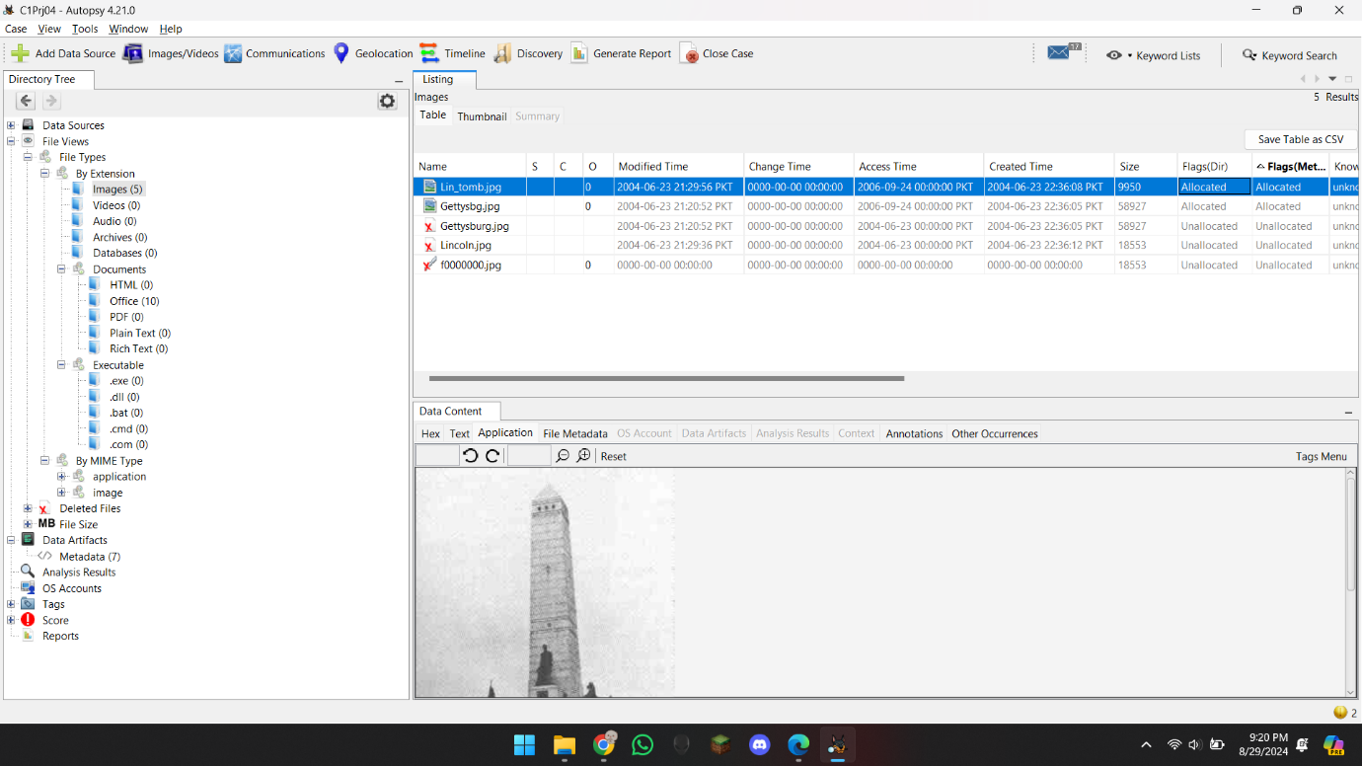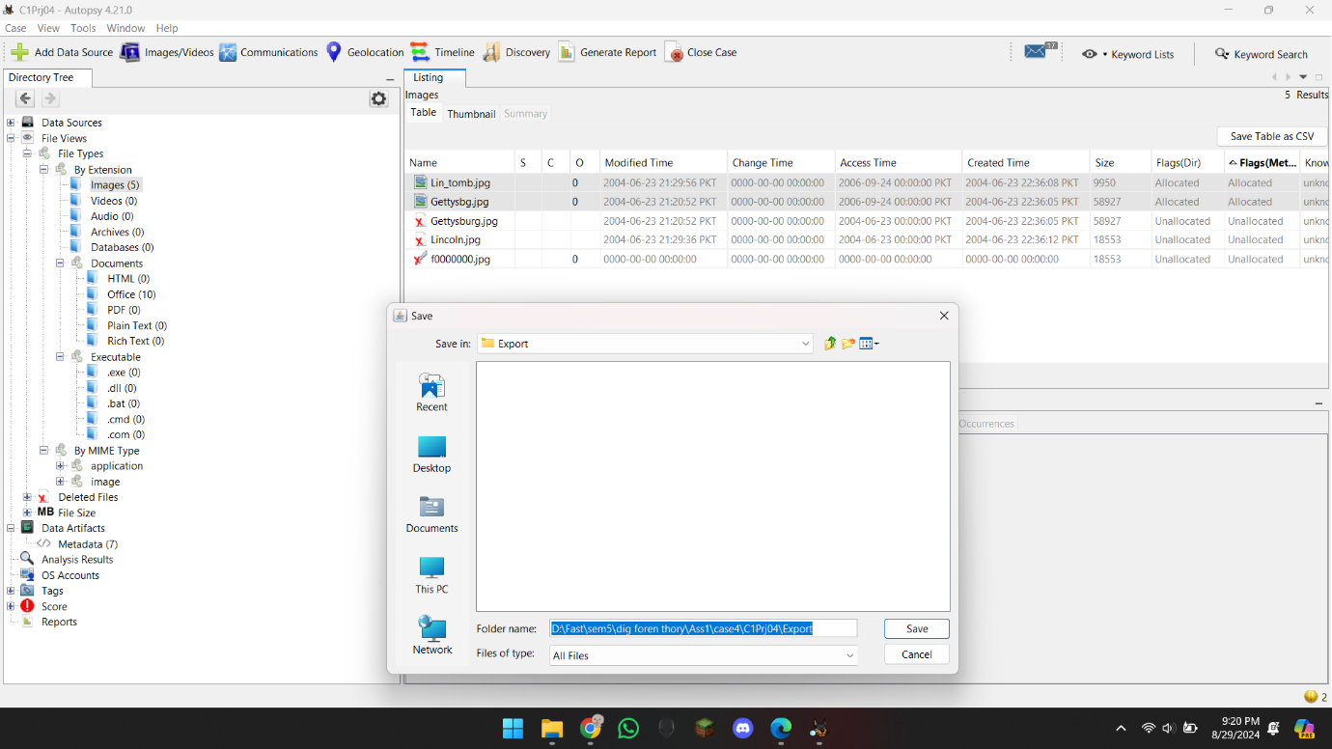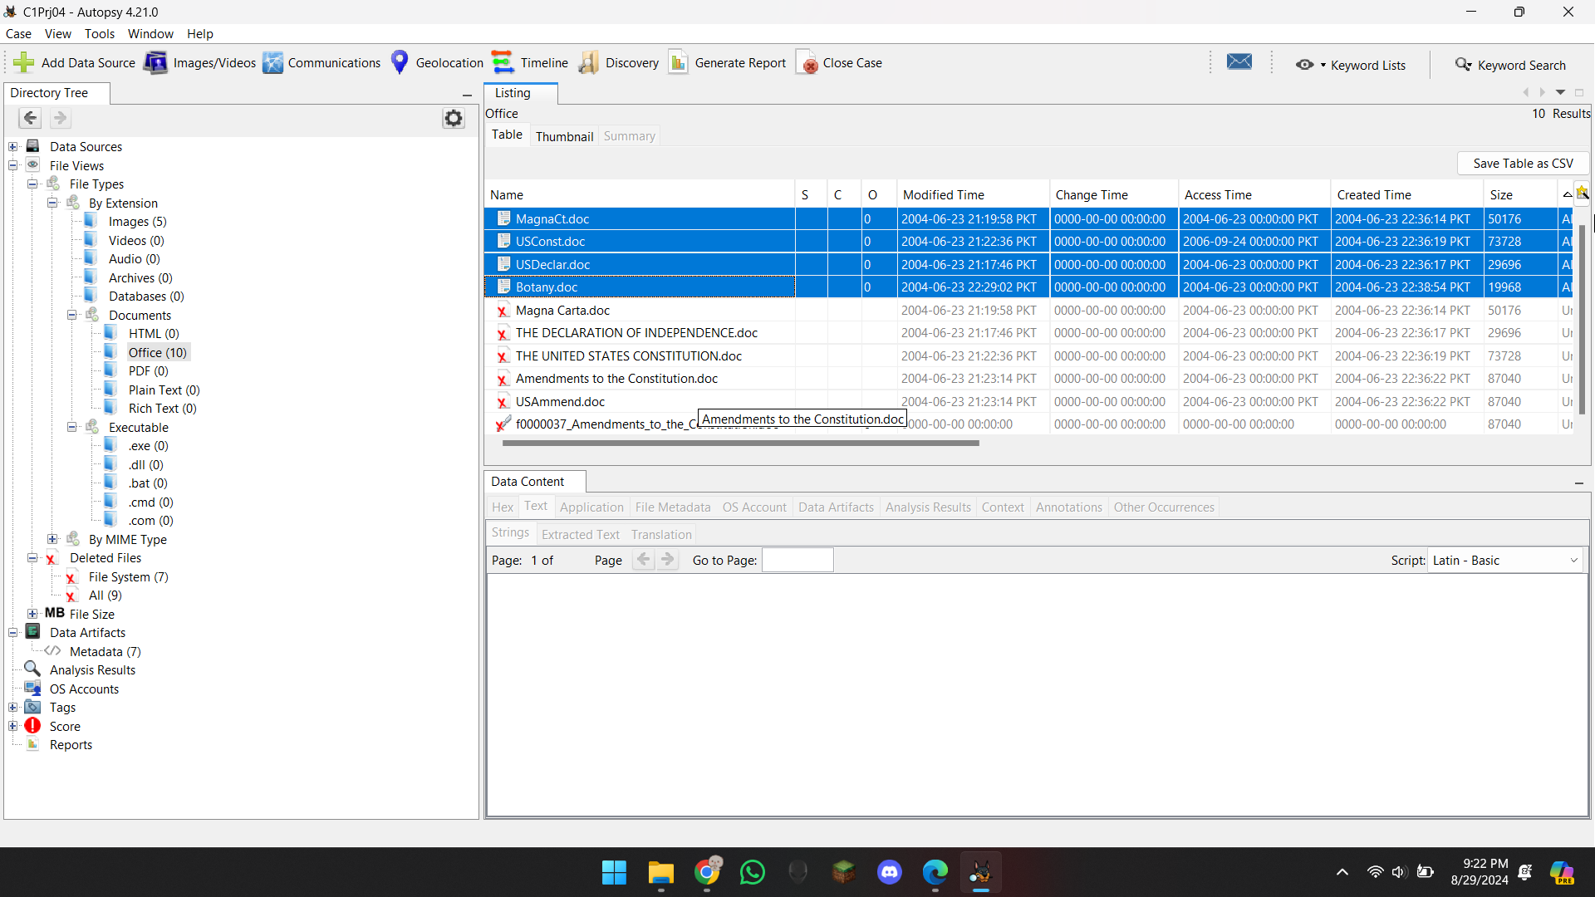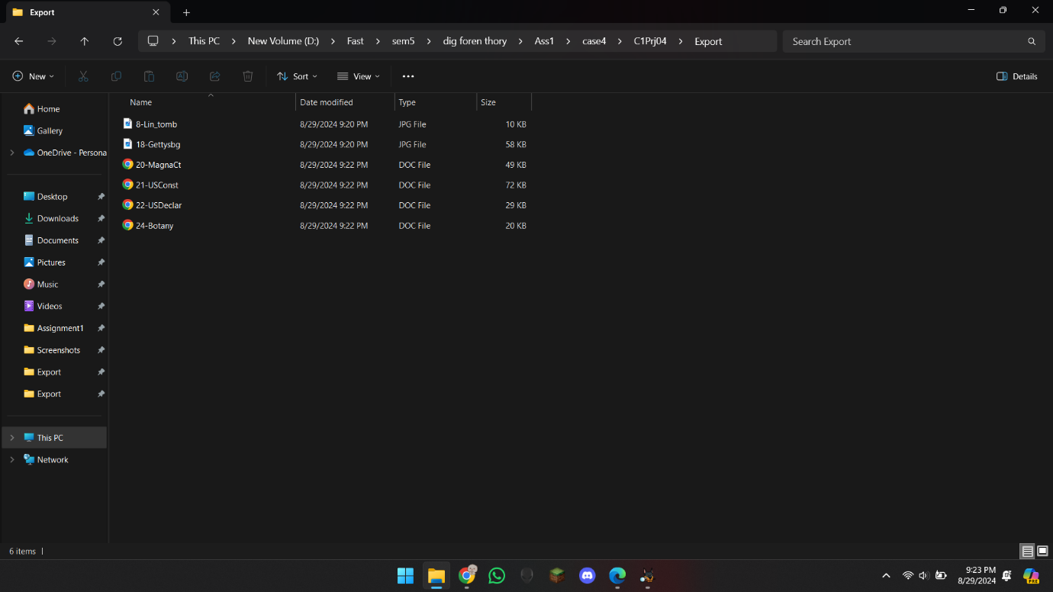

## Hands-On Project 1-5

It was just the continuation of previous project where I had to make a report of Deleted files.

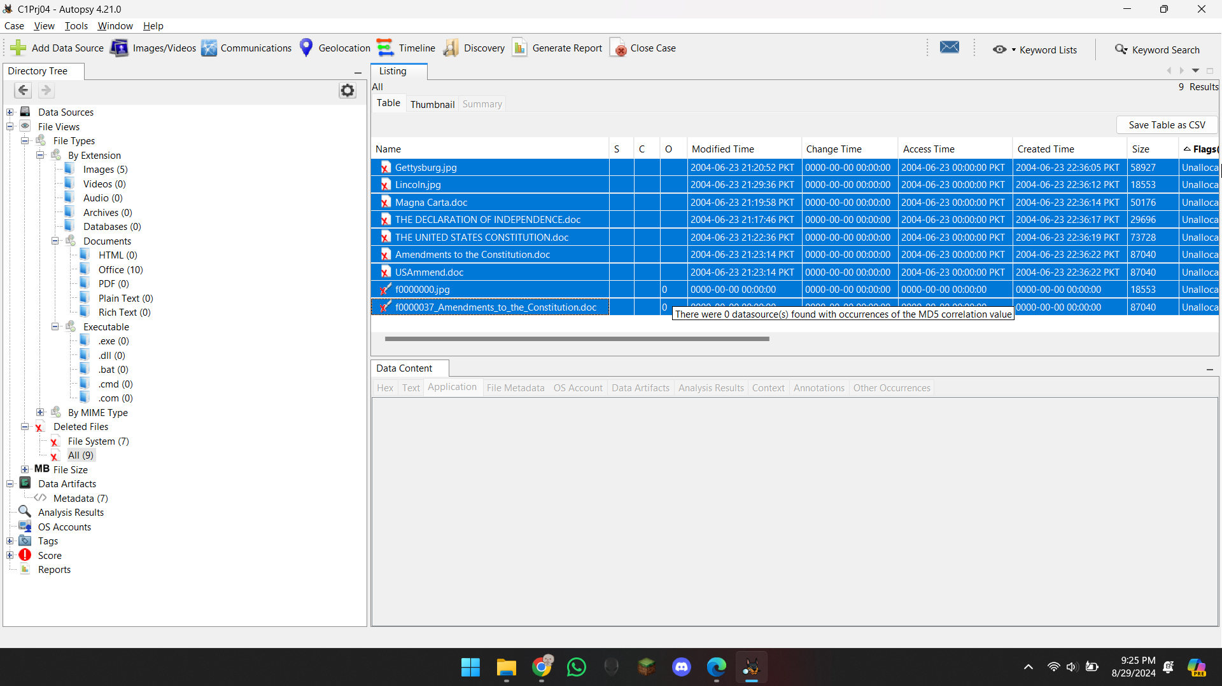For that I just tagged the files, and generated the excel report.

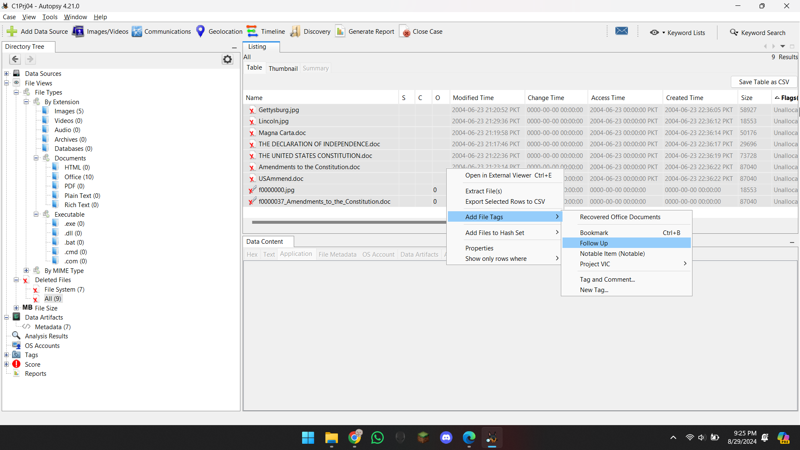

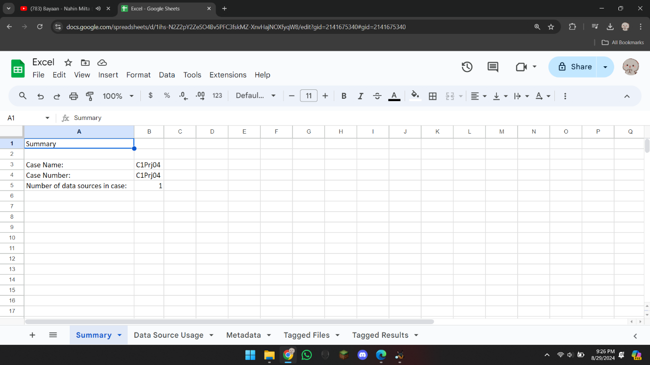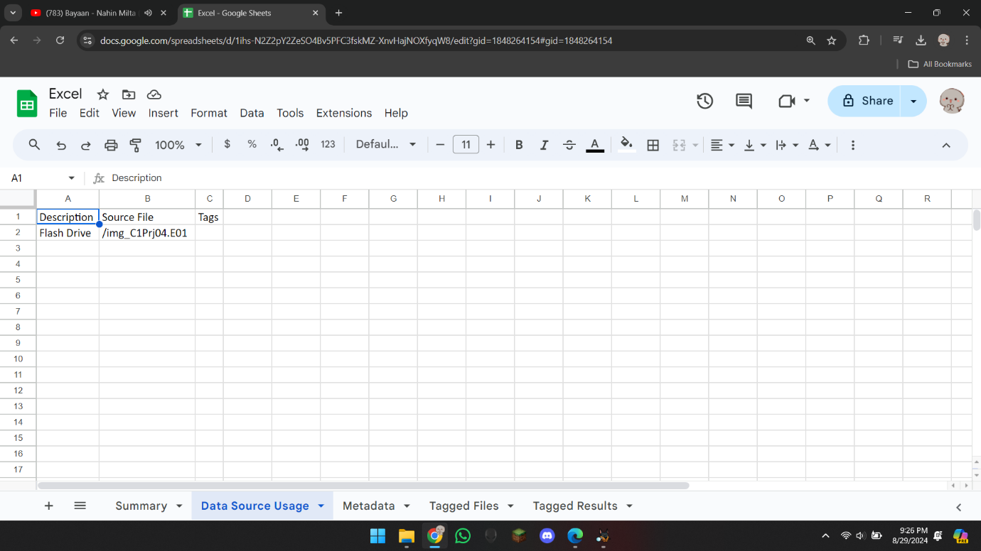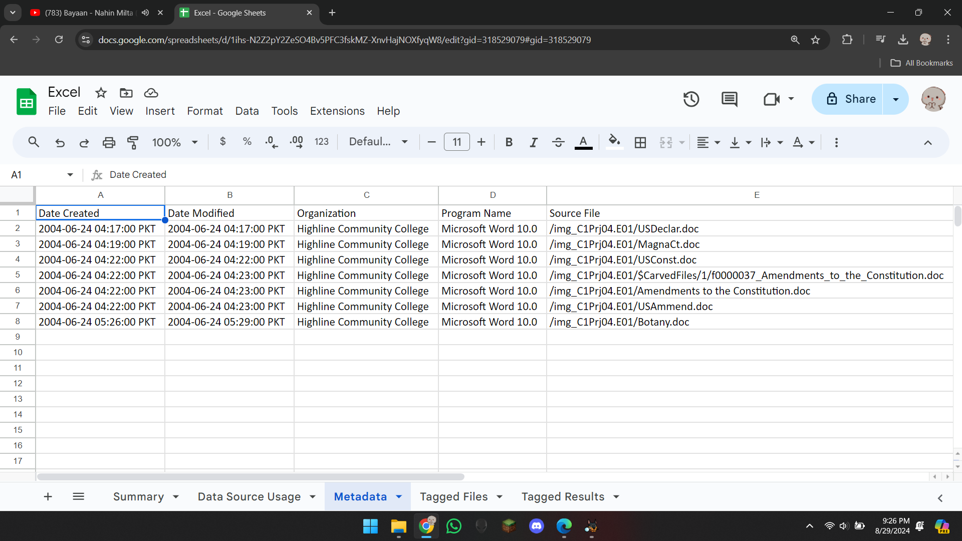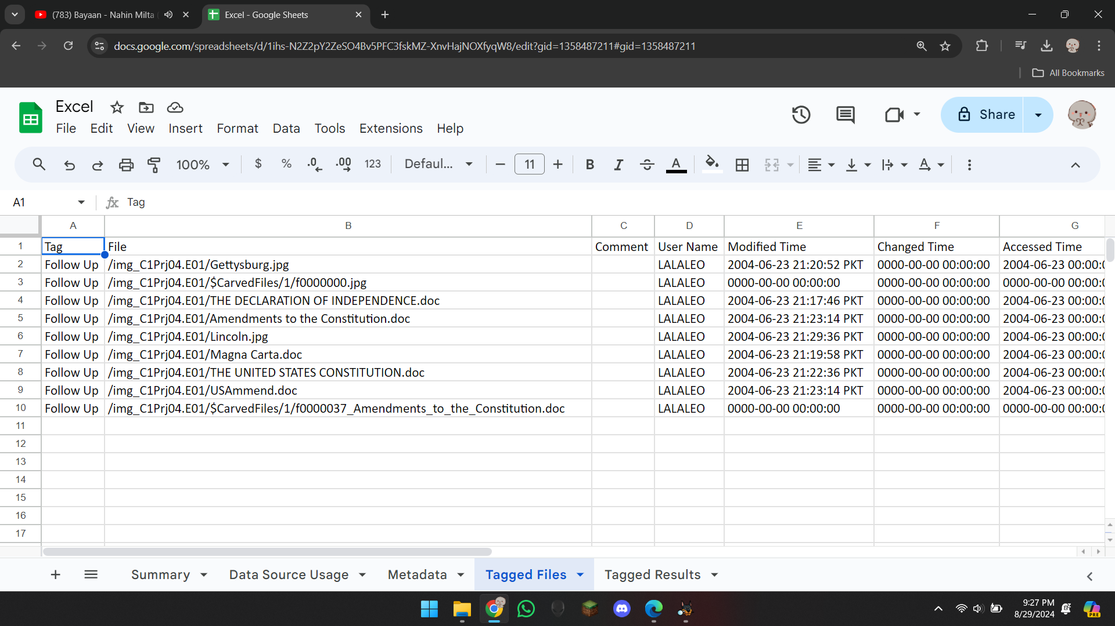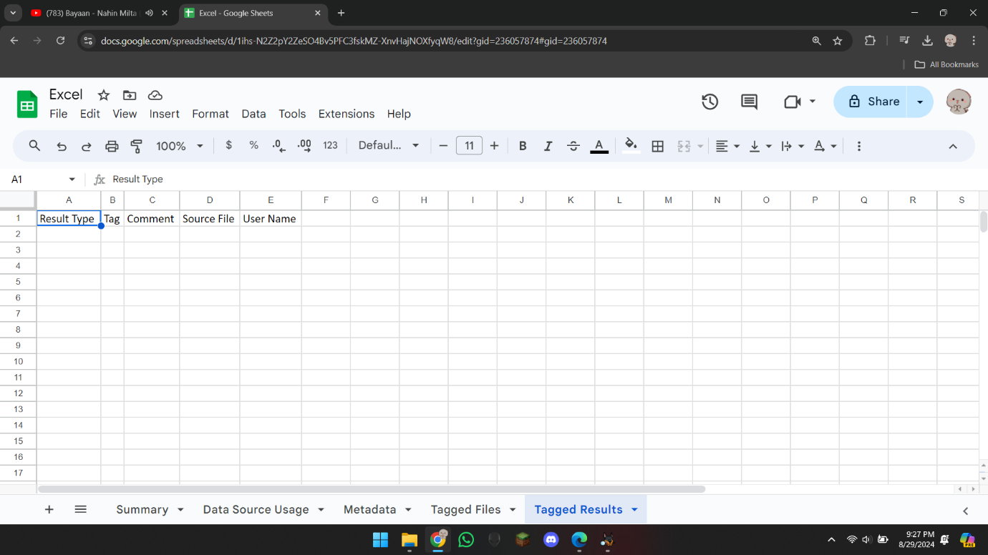

## Hands-On Project 1-6

In this project we had to find files according to a list of Words. So, I opened the project in Autopsy.

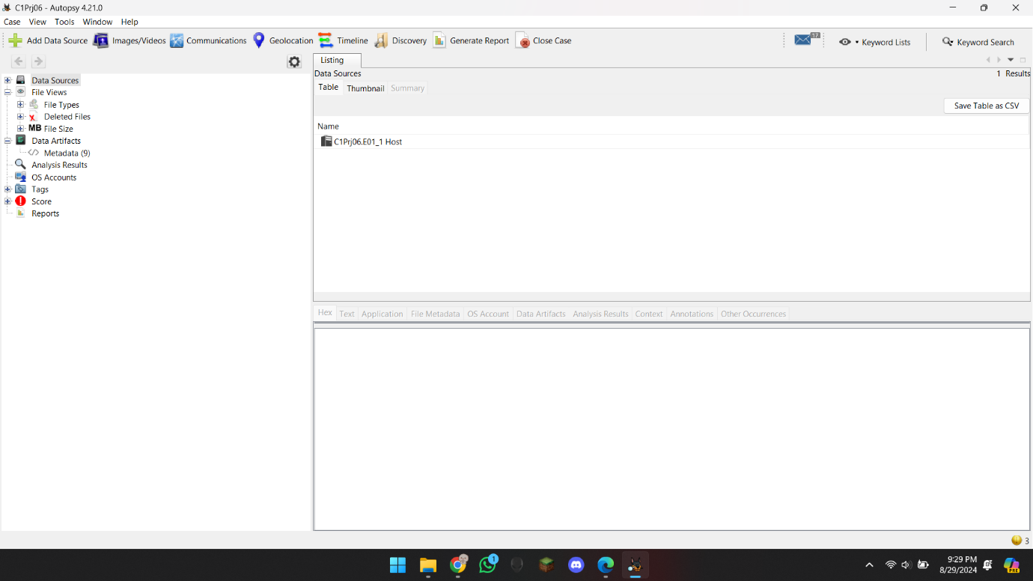

Then I just made a keyword list, and added the list, and searched it according to the list.

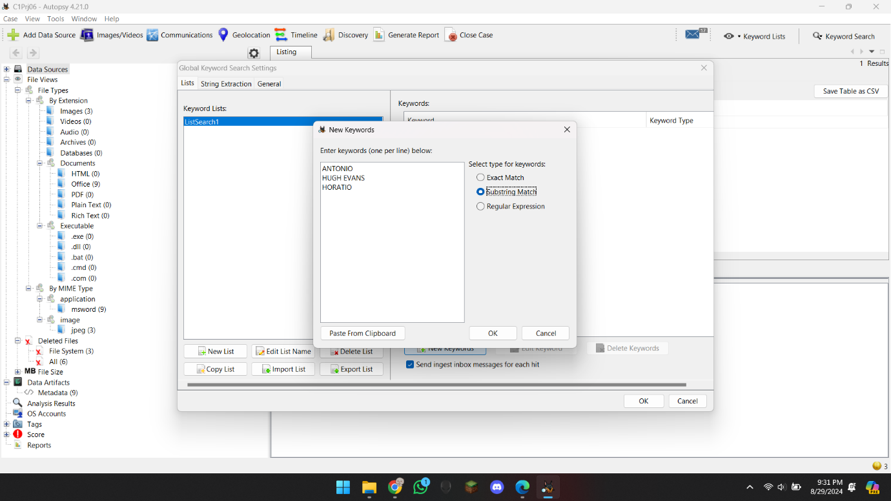

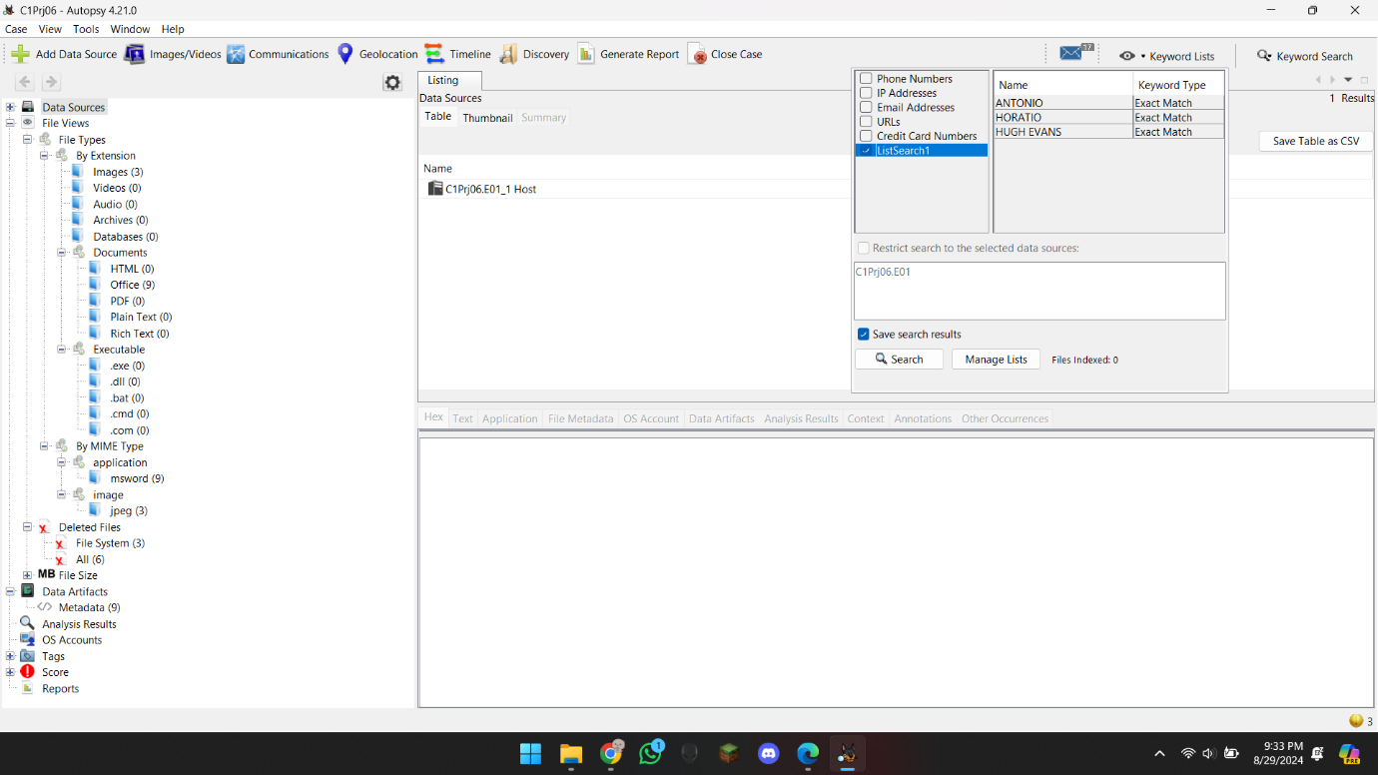

And I found these 5 files.

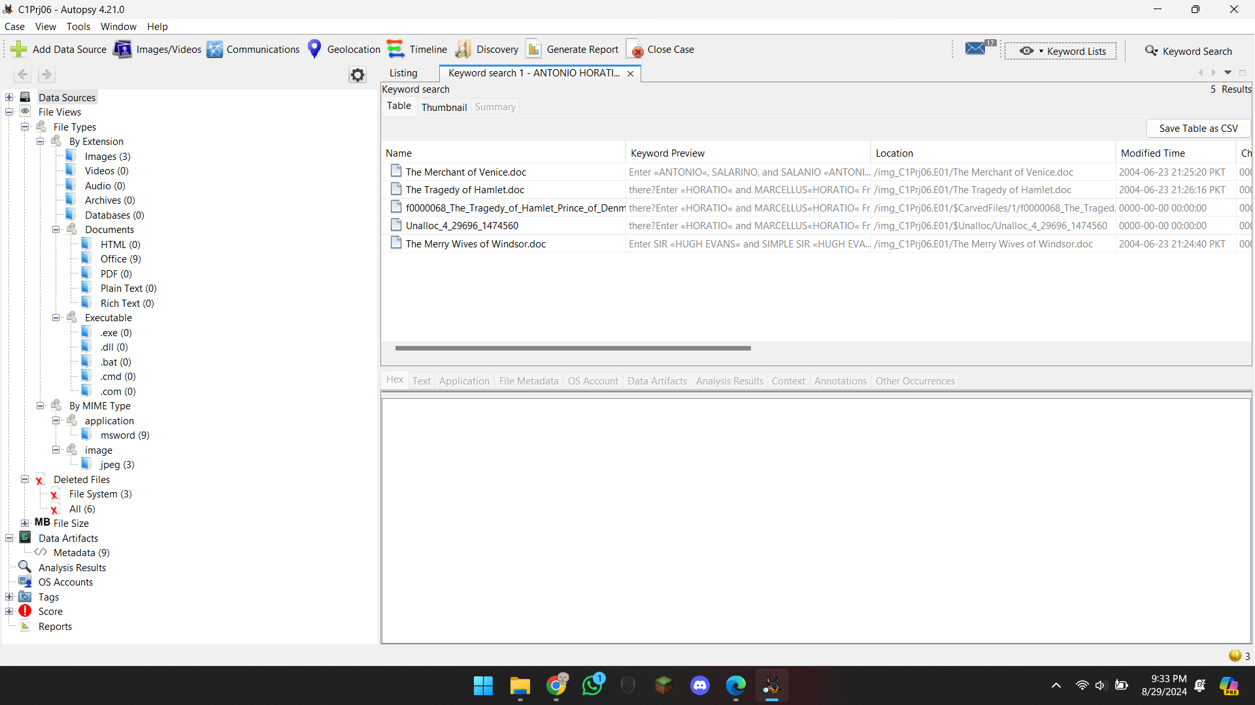

Now here it was a question that was find confidential file, I searched the keyword of confidential in every file but could not found any, then I thought there is a picture, but have some data inside it, so it could be confidential, but I just tagged all the files, because any file could be confidential, so I exported the HTML report and here it is.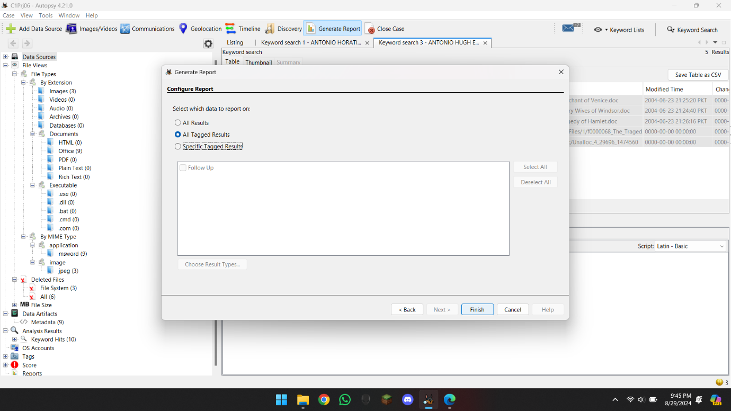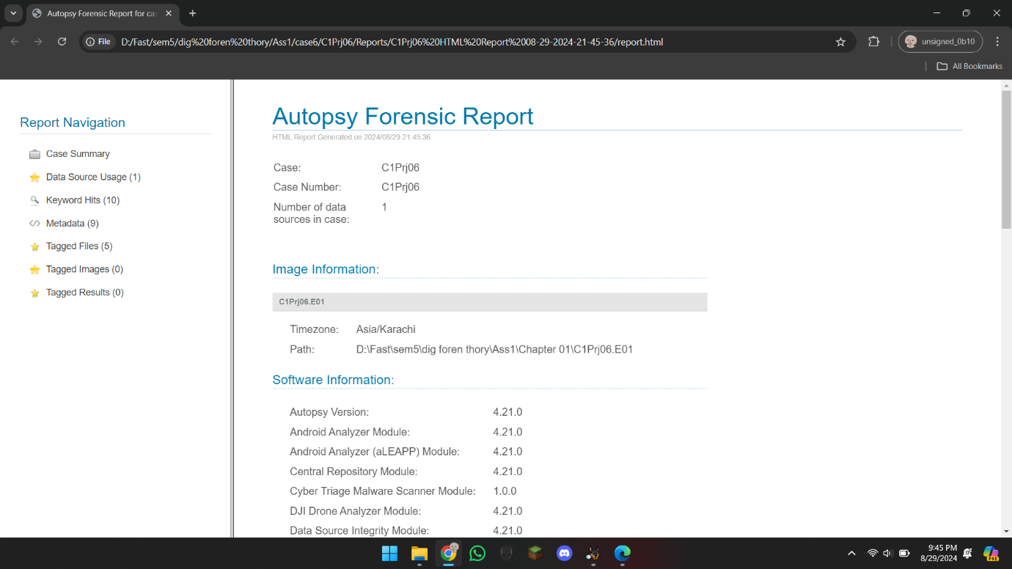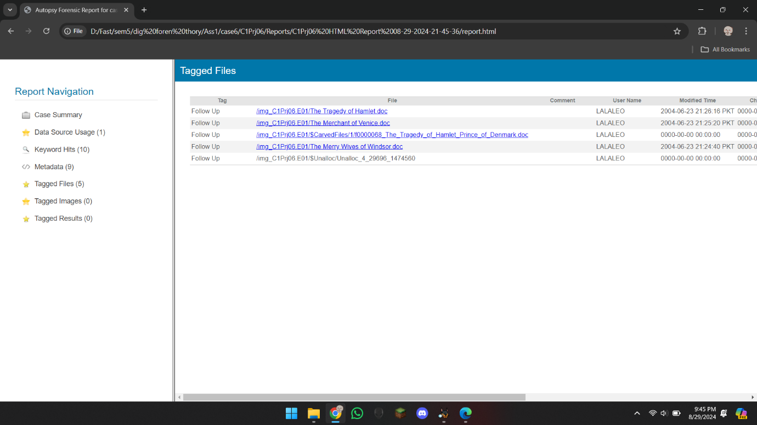

# **Summary**

In summary I wanted to say that this assignment was really good, and I had quite fun doing it although it was a bit basic, but still a great start, looking forward for Assignments like this in future that can help us Work in Industry.

# **References**

* Nelson, B., Phillips, A., & Steuart, C. (2003). *Guide to Computer Forensics and Investigations.*